**Module 2 Lab 1: Building a Simple Web Application Using Node.js and EJS**

Naga Sumanth Vema

IFT 554: Middleware Programming & Database Security

Dinesh Sthapit

February 04th, 2024

**Module 2 Lab 1: Building a Simple Web Application Using Node.js and EJS**

Screenshot 1: Terminal displaying the initialized Node.js project, showing the npm init -y command and its output.

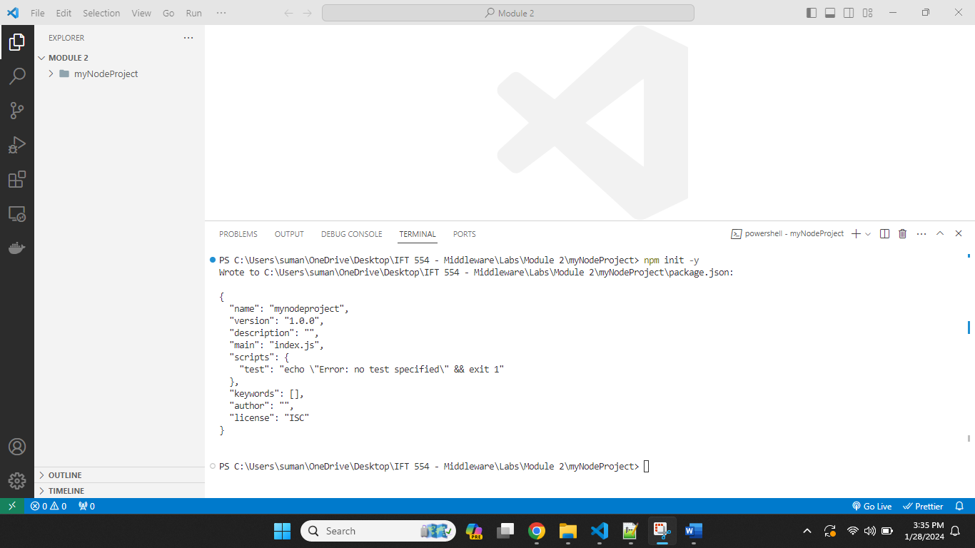

Screenshot 2: Terminal showing the successful installation of Express.js (npm install express) and EJS (npm install ejs).

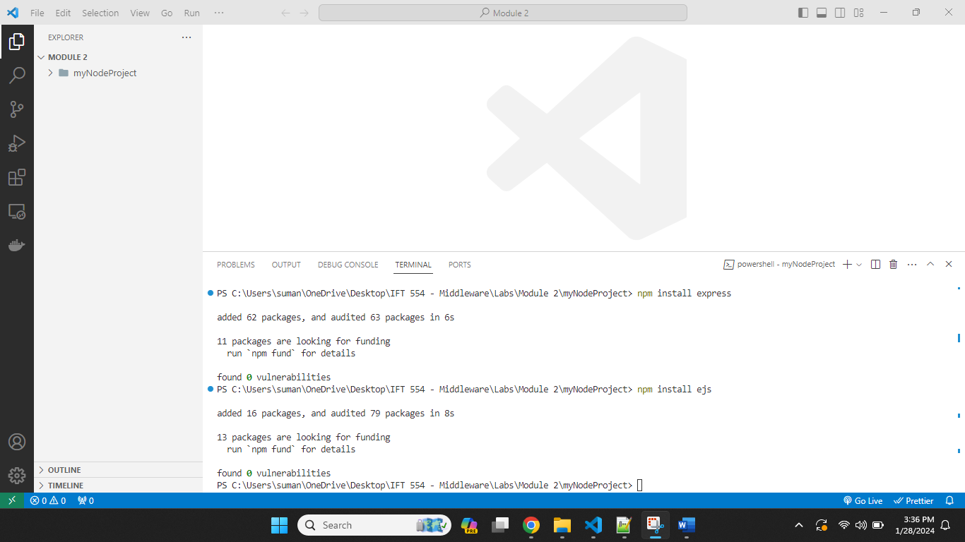

Screenshot 3: app.js file open in a text editor, displaying the code for setting up the Express.js server.

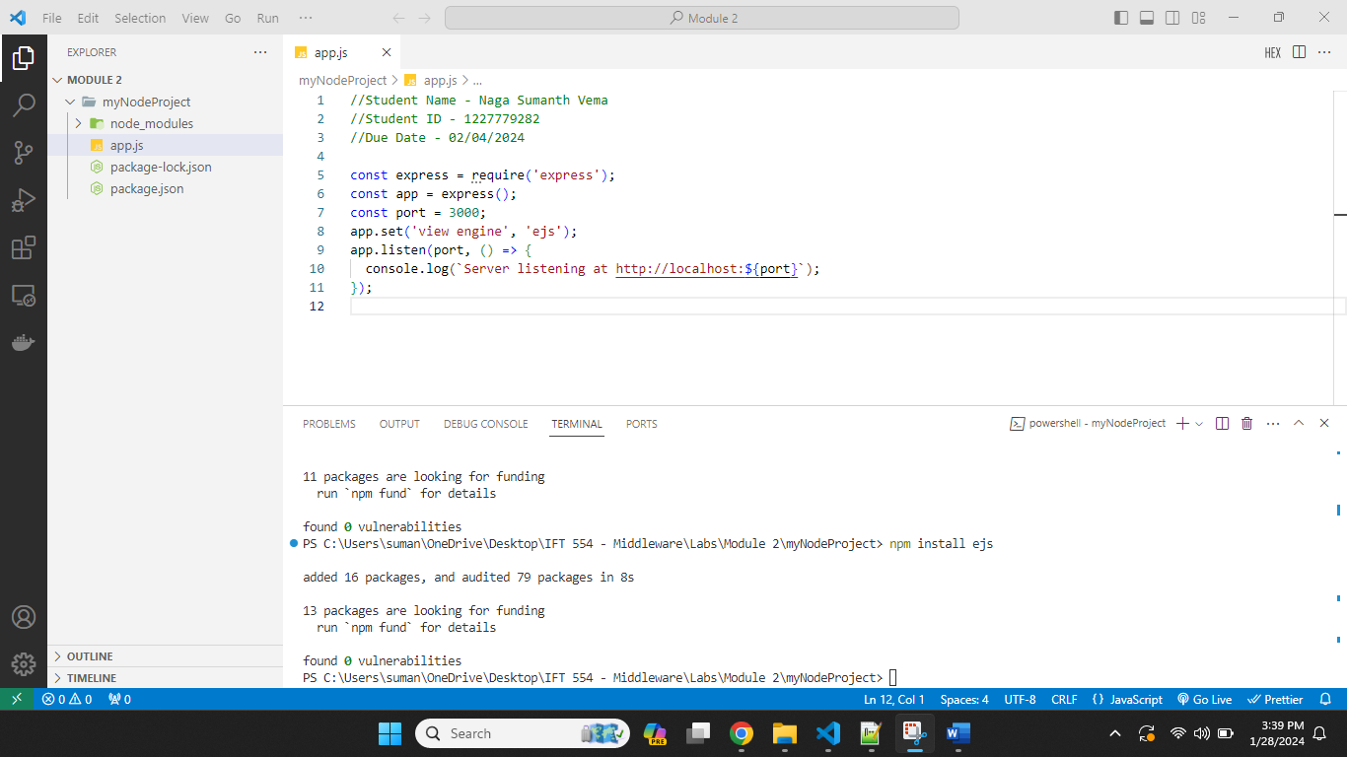

Screenshot 4: Project directory structure in the text editor, showing the newly created views folder.

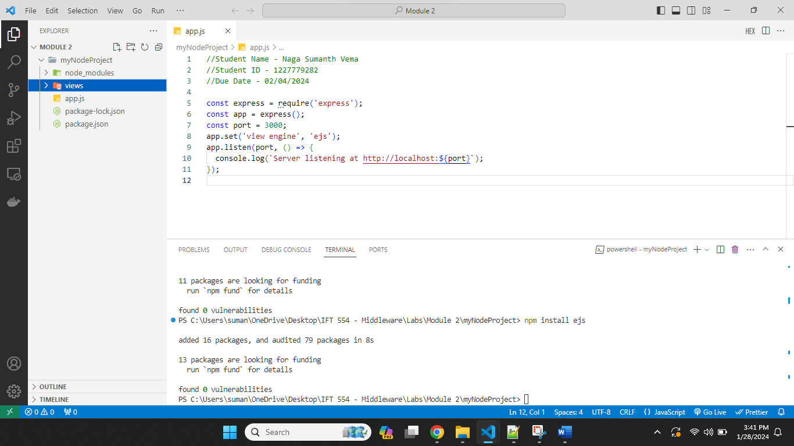

Screenshot 5: form.ejs file open in the text editor, displaying the HTML code for the student information form.

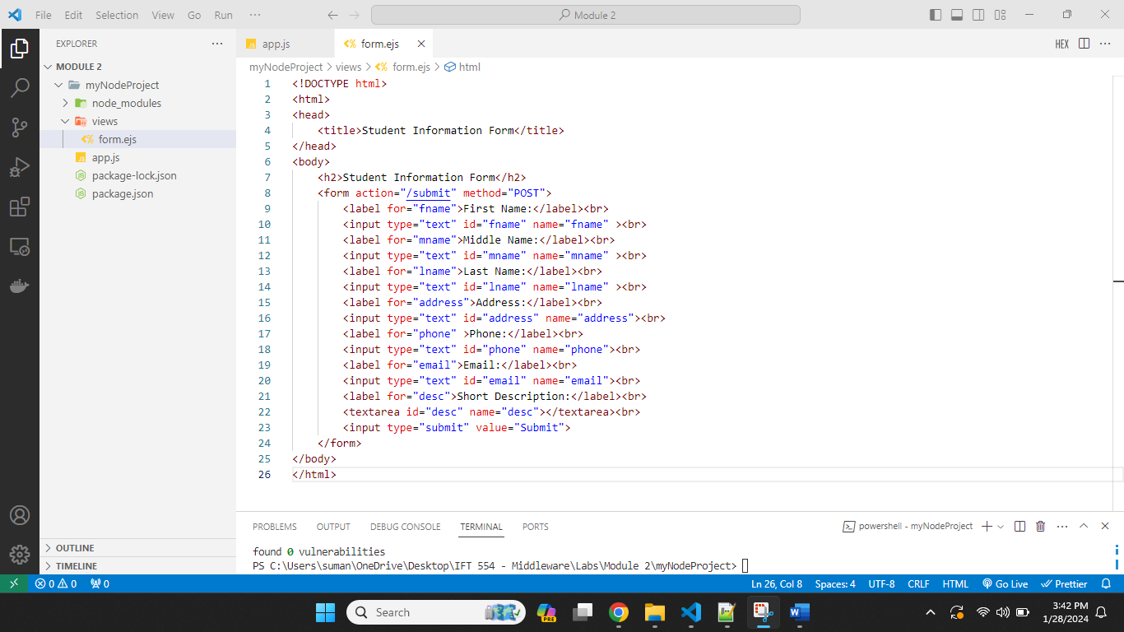

Screenshot 6: app.js file showing the added code for serving the form and handling form submissions.

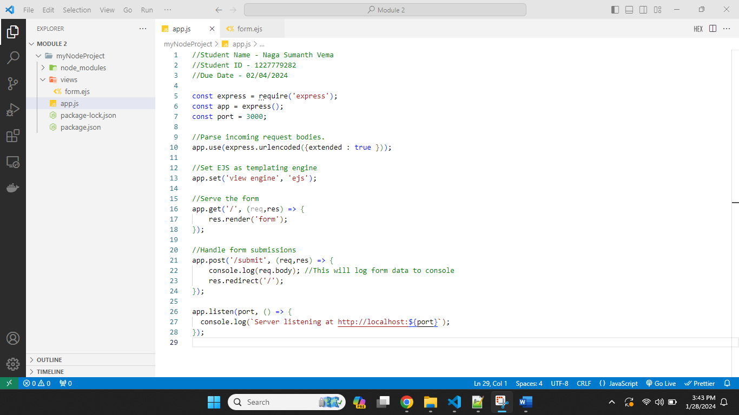

Screenshot 7: Terminal executing the node app.js command to run the Node.js application.

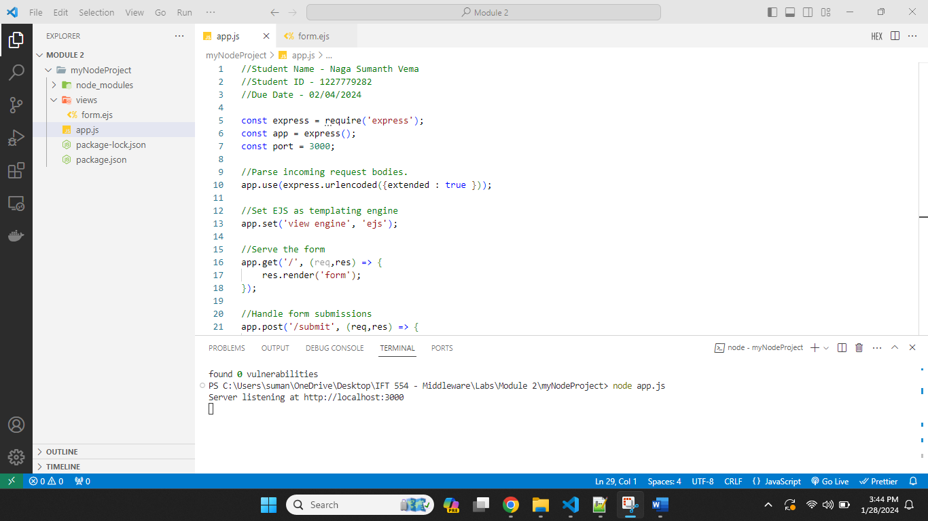

Screenshot 8: Web browser displaying the student information form at <http://localhost:3000>.

